Phylogenetic Tree Reconstruction using Proteins and their Matrices: The Matrices Effect on the Resulting Phylogenetic Tree using Maximum Likelihood

Evelynn Rhodes
Florida State University
ISC 4933: Computational Evolutionary Biology
Peter Beerli
December 12, 2024

Introduction
Background

Reconstruction of Phylogenetic Trees and the Importance of Protein Reconstruction
In the Computational Evolutionary Biology course, we have focused on phylogenetic trees with topics such as likelihood, parsimony, the coalescent, and how to implement these ideas into Python code. With these topics, input data in some projects would consist of a nucleotide sequence. The topic I wanted to look more into was tree reconstruction, which could be calculated with maximum parsimony, specifically Sankoff’s parsimony since it utilized a cost matrix. Sankoff’s parsimony consists of using a cost matrix of one nucleotide mutating into another to determine which possible tree has the least cost, which is a way to find “the best” phylogenetic tree to describe individuals. Since we have also worked with nucleotides for most of the semester, I wanted to look into protein sequences to see the ancestor DNA sequences, seeing the result of transcription and translation of ancestor DNA can tell us more about how the DNA was condensed and how that could lead to different bodily processes and functions. By comparing the environment ancestor species lived in, conclusions could be drawn about whether changes in amino acid sequence and thus their structure and function developed from blind chance, functional optimization, or constraints ( Hochberg and Thorton, 2017).

Protein Matrices and Their Development

PAM (point accepted mutation)
The PAM, or point accepted mutation, matrix was developed in 1978 by Margret Dayhoff. This matrix was based on looking at closely related proteins and their aligned sequences to see when there were accepted point mutations. The process of accepting point mutations involves two steps as described by Dayhoff, the change in the gene template that causes the mutation and the acceptance of the mutation of the species to favor that amino acid mutation. From the data of these sequences, a 20 x 20 matrix was created showing how frequently an amino acid would mutate to another. Because of the similarities in proteins to construct this matrix, 35 of the possible 190 combinations were never shown as the mutation would have to have more than one nucleotide of the codon to change (Dayhoff, 1978). The matrix did support some chemical properties of amino acids, such as the largest amount of exchanges happening between aspartic acid and glutamate, which are the only negatively charged amino acids. They are also very similar in their codon sequences, with both having mRNA sequences that start with G-A.
The PAM matrix has shown that the observed data can match the chemical properties of amino acids. However, the matrix model was scaled through matrix multiplication for longer distances, such as PAM250 which assumes 250% divergence, allowing more multiple mutations at a single site, only one in five amino acids would remain unchanged. This scaling does not account for some amino acids that remain more conserved such as methionine as it’s incredibly rare for methionine to mutate as it’s the start codon for proteins, even after an incredibly long time.

BLOSUM (BLOck SUbstiution Matrix)
Steven Henikoff and J G Heinkoff constructed the BLOSUM matrix in 1992. To construct this matrix, blocks of highly conserved protein sequences were observed and joined together in analysis, with lowly conserved areas in between not analyzed. The BLOCKS database they used had sequences that were at least 62% similar, resulting in more variability than PAM analyzing sequences that were at least 85% similar (Henikoff and Henikoff, 1992). This matrix differs from PAM as in 1992, we had more protein data compared to 1972, so the data was more varied and wide. The data was also more varied and wide as BLOSUM used less similar sequences, which allowed for more tolerance for proteins that would rarely mutate and looked at rarer protein substitutions.

JTT Matrix ( Jones-Taylor-Thornton )
Also in 1992, Jones, Taylor, and Thorton wanted to update the PAM matrix. Using the same method as Dayhoff, the research team constructed an updated PAM matrix. This had updated the values to match more modern data. Notable differences were seen in the comparison such as the most mutable proteins being asparagine and serine to being serine and threonine (Jones et al, 1994). With the more recent data, but still looking at very closely related proteins, it could change the phylogenetic tree reconstruction from PAM, BLOSUM, and the JTT matrix.

Methods

Python Codes
ChatGPT was used to help create Python code for the reconstruction of trees. The Python code consisted of 3 executable codes. Tree.py was developed in the Computational Evolutionary Biology class, this code can build phylogenetic trees by manually adding nodes or from the input of a Newick string, the code can also output a Newick string or a comprehensible tree using indentation. The code was made by creating the main tree object that is used to store nodes and define relationships between the nodes and an object of treeNode that stores the data for each point in the tree. The next code is Phylip.py, which takes in a file in Phylip format to create nodes and store the sequence to individuals specified in the Phylip document(originally for nucleotides, but in this report is used for amino acid sequences). The last executable code is Reconstruction.py, the main code where the input is a PHYLIP document of species and their amino acid sequences and a specified protein matrix. The output is a Newick strand that infers the relationship between individuals.
Reconstruction.py is the main script that performs creating the tree from the Phylip file and the likelihood calculations. Originally Reconstruction.py would only have a Newick string as output, and the main function was a UPGMA algorithm that would use a neighbor-joining method to find the two sequences with the least amount of cost according to the input matrix, join those two nodes together, and then compare those 2 nodes as a single node to all the other sequences. For the matrix input, the program would create a JSON file, which is a dictionary with the key being the amino acid pair and the value being the cost to go from the left amino acid to the right.
However, one of the main ideas of this project was trying to estimate the ancestor amino acid sequence, so the code was updated to accommodate Maximum Likelihood. This code created a new class with data members of the PHYLIP file and the substitution matrix.
During initialization, the class performs several important tasks. First, the substitution matrix is loaded using the load_matrix function. This function parses the provided matrix file into a dictionary where each amino acid serves as a key, and its value is a nested dictionary containing scores for transitioning to other amino acids. This data structure ensures efficient lookups, which are critical for ML-based calculations. Next, the PHYLIP file is read using a function from Phylip.py to extract amino acid sequences. Finally, the calculate_stationary_frequencies function computes the relative frequencies of amino acids from the sequences in the PHYLIP file, which are later used to weight likelihood calculations.
To construct the phylogenetic tree, the construct_tree_stepwise function uses a stepwise addition algorithm, inspired by methods like UPGMA. This approach iteratively identifies the two nodes with the smallest distance between them, creates a new parent node, and assigns the closest nodes as its children. Distances are calculated using the compute_pairwise_distances function, which fills a distance matrix by repeatedly calling compute_distance. Compute_distance will take the amino acid from one sequence and the amino acid from another sequence to calculate the distance between them using the supplied substitution matrix.
The final reconstruction process is orchestrated by the reconstruct function, which builds the initial tree using the stepwise process. It then calculates likelihoods by calling _prune and _compute_total_likelihood. The _prune function sets likelihoods at each tree node and reconstructs the amino acid sequences, Once the likelihoods for all positions and amino acids are calculated _prune determines the most likely amino acid at each position for the current node. For leaf nodes, likelihoods are set to 1 for observed amino acids and 0 for all others. For internal nodes, the function propagates likelihoods from child nodes, scaling transition probabilities by branch lengths derived from the substitution matrix. The _compute_total_likelihood function aggregates these likelihoods at the root node, weighting each amino acid by its stationary frequency to compute the total likelihood.
For the substitution matrix used, this should mainly affect the likelihood score and if the amino acids sequences are different enough to leverage the slight differences in each matrix, it could affect the order of relations.

Inputs
One of the inputs was a specified protein matrix. These protein matrices were stored in a text file with similar formats. The matrices used were PAM250, BLOSUM45, and a scaled version of JTT. In the paper that described BLOSUM, the creators of the BLOSUM matrix compared derived matrices to PAM’s derived matrices, from this BLOSUM45 and PAM250 were comparable matrices (Henikoff and Henikoff, 1992). As for JTT, I couldn’t find any derived matrices, so by asking ChatGPT to scale the JTT matrix up to BLOSUM45, the matrix was scaled by 0.8. The PAM250 matrix and the BLOSUM45 matrix were given from NBCI’s Informations Engineering Branch toolbox (“IEB toolbox,”). The original JTT matrix was from the original paper done by Jones, Taylor, and Thorton (Jones et al 1994).
The other input was a PHYLIP document containing individual species and their amino acid sequences, some of these sequences were derived from commonly known proteins such as hemoglobin and Cytochrome C. These sequences were from the species Frog, Mouse, Human, and Chimp, and the sequences were found on UNIPROT.org. For the second program that deals with likelihood, the mainly tested example was a simulated amino acid sequence via ChatGPT that created sequences for Humans, Chimps, mice, and ducks.

Results

Before Implementing Maximum Likelihood
Before implementing maximum likelihood and just using the substitution matrices to determine which sequences have the least distance between them and then making those nodes siblings, the main effect of the substitution matrices was scaling. This can be seen in Figures 1A, 1B, and 1C which represent the Newick string output from using PAM250, BLOSUM45, and the scaled JTT matrix respectively These Newick strings were also visualized using the ETE Toolkit (“Phylogenetic tree (Newick) viewer,” ). The input for these was a PHYlP file containing 50 amino acids for cytochrome C data from frogs, mice, humans, and chimps. These species were chosen as it was easy to predict how the tree should look. The changes in the time scale could be explained by how the matrices were made. PAM250, which only looked at very similar sequences during the creation of the original PAM matrix, was expanded to PAM250 by matrix multiplication and had a time scale shorter than BLOSUM45. BLOSUM45’s tree had the longest time scale as it looked at more varied data with fewer similarities than PAM, which allowed for the cost to go from one amino acid to another to increase overall since data was not as highly conserved as PAM. The JTT matrix had the shortest time scale, this was unexpected as the JTT matrix is a modern version of PAM that also looked at similar data, however, it had more varied data. The result could be explained by the JTT matrix providing more proof of high exchange between certain amino acids than PAM, allowing the cost to be lower for some highly exchanged amino acids and so the overall distance is lower in highly conserved sequences. Another explanation could be investigating if the scale of the JTT matrix was efficient and accurate.

Implementation of Likliehood
For the second code created that also calculated likelihood with each matrix, there are figures down below showing the output of the ML.py code, this code looks at proposed amino acid sequences from the ancestors, the Newick string (also visualized with ETE Toolkit), and the final likelihood. Figure 2A shows the results of each simulation, run in the order of PAM250, BLOSUM45, and the scaled JTT Matrix. From these results, the likelihood was not changed and the order of relation has not changed either between simulations. What is most interesting is the difference between the reconstruction of ancestor nodes between PAM and the other two matrices. BLOSUM45 and the JTT matrix were identical while PAM showed a very different sequence. These changes show that there are differences in how each matrix viewed the mutability of each amino acid. The JTT matrix and the BLOSUM matrix could be very identical as they had the same data available at the time of making the matrix. The scaling is another main difference when compared to the last program, BLOSUM had the longest time scale with PAM250 in the middle, PAM250 now being the longest time scale could be due to the randomness of the amino acids, which may leverage some of the main differences in the PAM250 matrix and the more modern matrices.

Discussion
The scaling differences between the matrices were evident in the branch lengths of reconstructed trees. BLOSUM45 produced longer time scales reflecting its emphasis on divergent sequences and rarer substitutions. Conversely, PAM250’s shorter time scale for the first part of this project aligns with its reliance on closely related sequences during its construction. The scaled JTT matrix produced the shortest time scale in the distance-based reconstruction phase, which was unexpected but may be due to its specific handling of high-exchange amino acid pairs, reducing the overall substitution cost for conserved sequences.
The calculated ancestor node sequences in the second program that implemented likelihood showed a very close similarity to BLOSUM and JTT, which may be due to both matrices being made around the same time, so they had access to the same data while PAM had a much smaller data set to work with.
This project underscores the importance of selecting appropriate substitution matrices based on the dataset and research objectives. While all three matrices provided meaningful results, the differences in scaling, ancestral reconstructions, and branch lengths illustrate how these tools can shape phylogenetic inferences. Understanding these differences is crucial for interpreting evolutionary relationships and protein function across species.
In the future, testing more diverse data sets and analyzing the matrix to see what amino acid exchanges are more than just a slight scale of each other depending on the matrix could provide insight into what changed over the decades in our collection of protein data and how that affects data sets. It would also be reasonable to test with real data if there are any ancestral protein sequences available to compare results from the model and real data.
During this project, I learned a great deal about computational phylogenetics, particularly the nuances of implementing phylogenetic tree reconstruction using protein substitution matrices. One significant aspect was working with ChatGPT to develop the Python code, which required careful oversight to ensure the algorithms and implementation were correct. Despite occasional difficulties, such as needing to refine or rework parts of the code, the collaborative process ultimately strengthened my understanding of tree reconstruction algorithms and likelihood calculations.

Figure 1A: The first program, reconstruction.py, tests with more similar amino acid sequences with PAM250 as the input
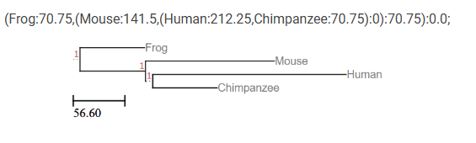
Figure 1B: The first program, reconstruction.py, tess with more similar amino acid sequences with BLOSUM45 as the input
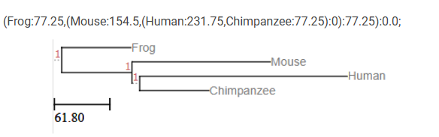
Figure 1C: The first program, reconstruction.py, tess with more similar amino acid sequences with scaled JTT matrix as the input
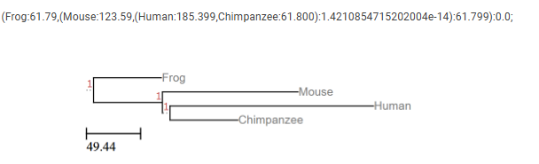

Figure 2A) Output of the second Python code, ML.py which implements likelihood. Tests ran in the order of PAM250, BLOSUM45, JTT.
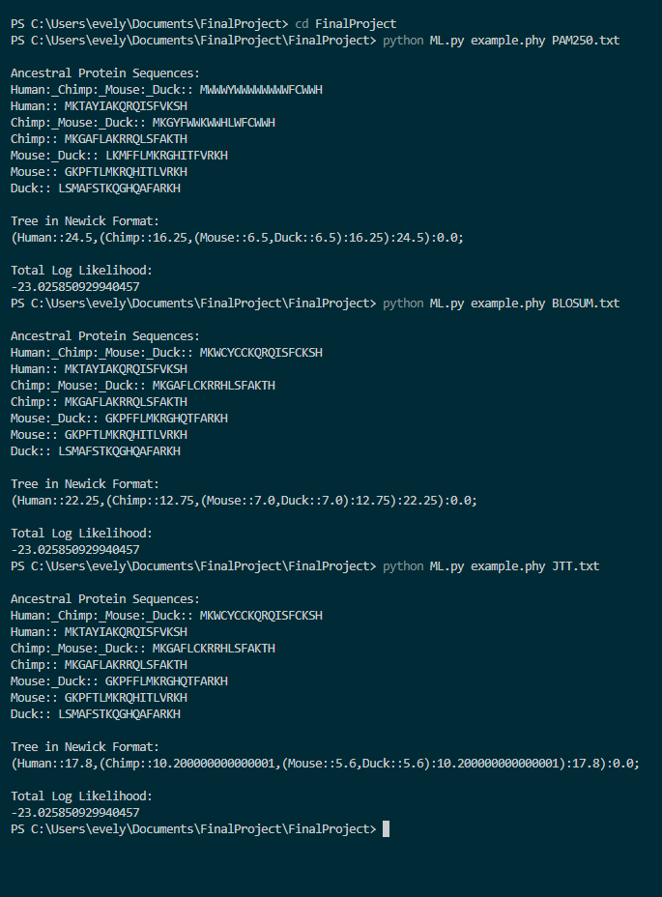

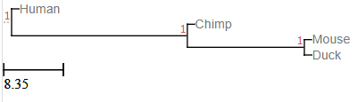
Figure 2B.2 shows the visualized phylogenetic tree of ML.py and the input of a PAM250 matrix

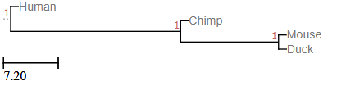

Figure 2B.2 shows the visualized phylogenetic tree of ML.py and the input of a BLOSUM45 Matrix

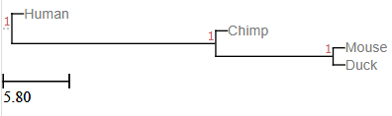
Figure 2B.3 shows the visualized phylogenetic tree of ML.py and the input of a scaled JTT Matrix

References
Dayhoff MO, Schwartz RM, Orcutt BC. A model of evolutionary change in proteins In: Dayhoff M, editor. Atlas of protein sequence and structure. Volume 5 Washington, DC: National Biomedical Research Foundation, 1978; p. 345–352.
Henikoff S, Henikoff JG. Amino acid substitution matrices from protein blocks. Proc Natl Acad Sci USA. 1992;89:10915–10919.
Hochberg, Georg K., and Joseph W. Thornton. “Reconstructing ancient proteins to understand the causes of structure and function.” Annual Review of Biophysics, vol. 46, no. 1, 22 May 2017, pp. 247–269, https://doi.org/10.1146/annurev-biophys-070816-033631.
“IEB toolbox,” National Center for Biotechnology Information, https://www.ncbi.nlm.nih.gov/IEB/ToolBox/MainPage/index/
Jones D, Taylor W, Thornton J. A mutation data matrix for transmembrane proteins. FEBS Lett. 1994;339:269–275.

“Phylogenetic tree (Newick) viewer,” Tree viewer - Online visualization of phylogenetic trees (newick) and alignments., http://etetoolkit.org/treeview/ (accessed Dec. 5, 2024).

